Applying for a New Apiary License Online and Other Online Information 2022

Applying for a New Apiary License (You do NOT have a license yet):
1. You will need your address, the address of the bee yard(s) (including county and township), and a credit card.

2. Go to the Pennsylvania Department of Agriculture’s link at https://www.paplants.pa.gov/SecurityLogin.aspx

3. It will take you to a page labeled: “Pennsylvania Department of Agriculture”.

-Click on “Apply for New License”.

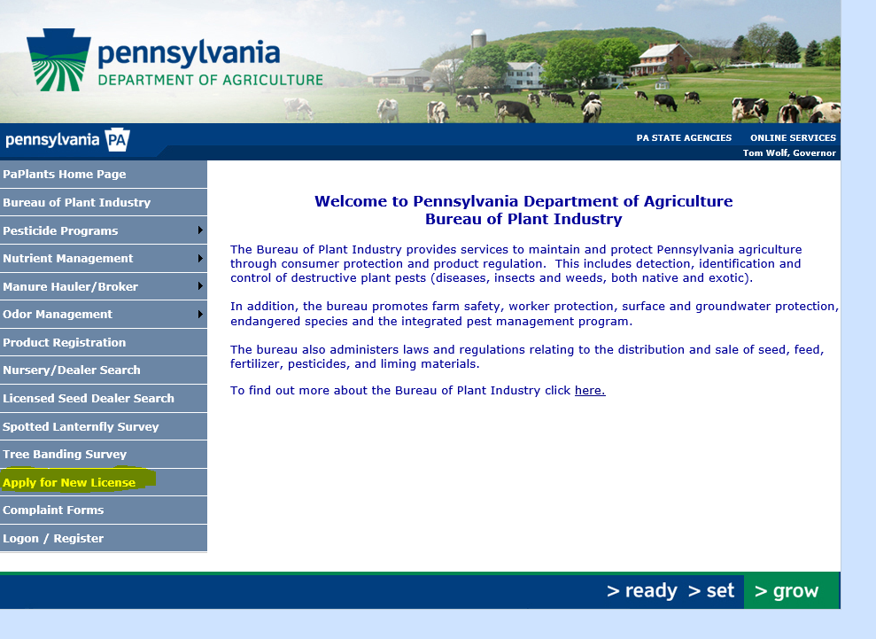

4. New License/Registration page
-At the drop-down box “Would you like to sign up for a new license or registration?”, click on the arrow and then select “Apiary”.

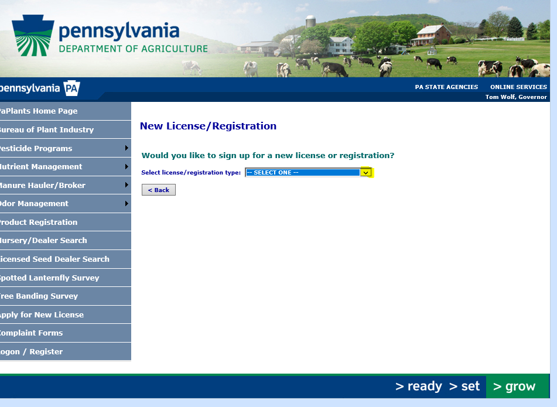

-Then this will appear near the top of the page: “Would you like to sign up for a new license or registration?”
Click on the box saying, “If not, ENTER NEW ACCOUNT INFORMATION”.

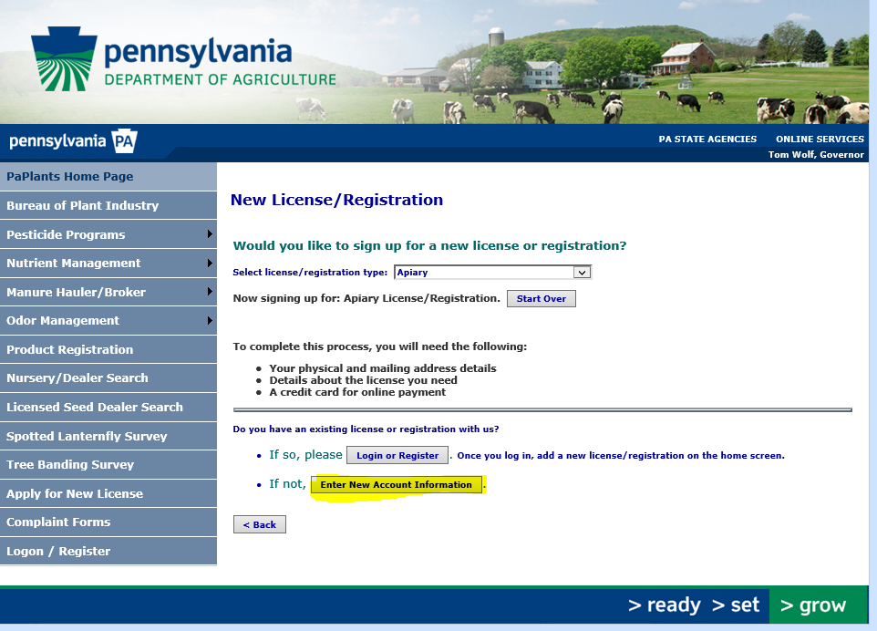

5. Registration Type Choices
-Note: If you see an *, then the information is required.
- Click on the drop-down box by “Type:” and choose “Business” or “Person”. If you select “Business”, the screen will look similar.
-If you select “Person”, this is the screen you will see.

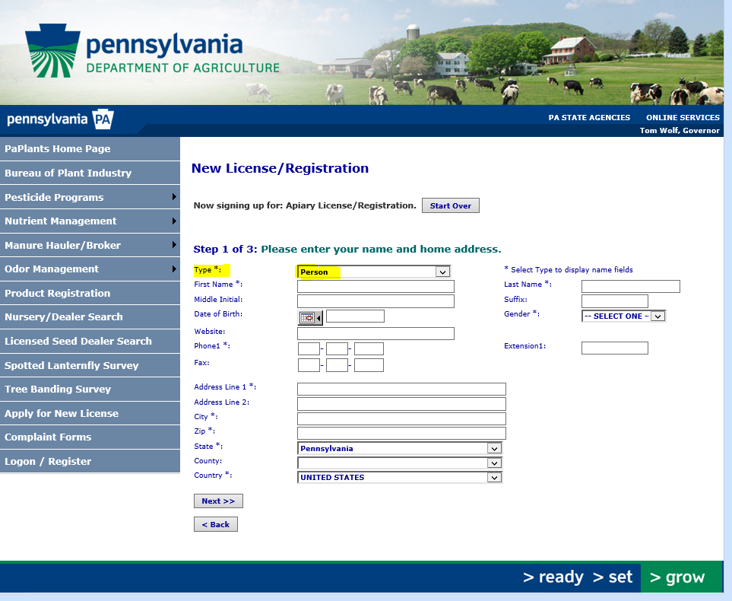

-You do NOT need to fill in your birthday information.
-You may enter “not applicable” for “Gender”.
- “Address Line 1*” is your actual physical home address. (This is important if you have a post office box. There will be a place for mailing address on the next “page”.)

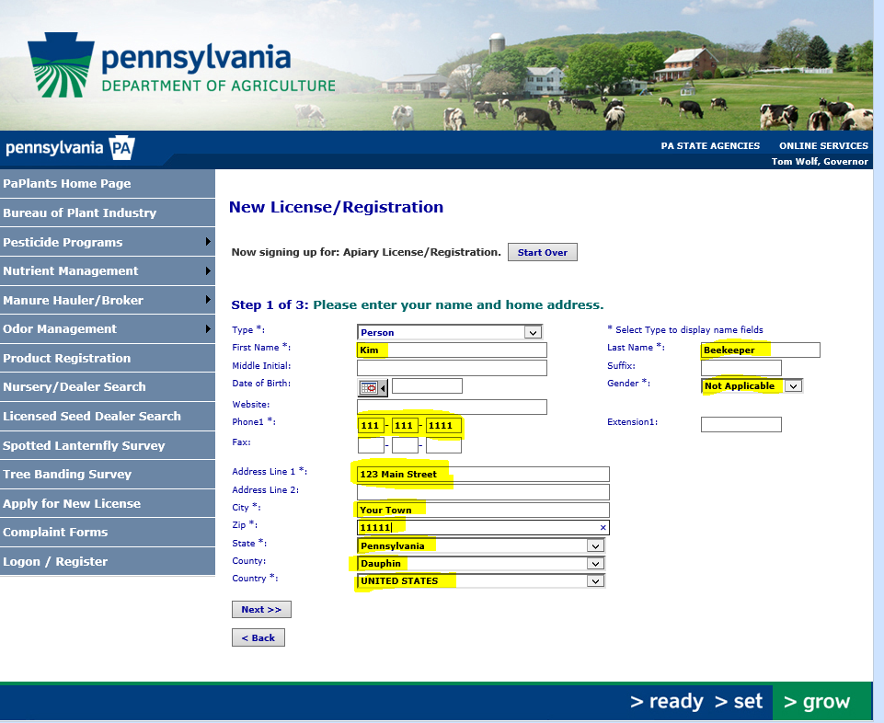

-Click “next” (near bottom of page) and continue to Step 2 of 3!

-This is where your home MAILING address is typed in. If your mailing address is the same as your home physical address, you can click in the box “Mailing address matches physical address” and it will automatically fill in the correct address. If you have a Post Office Box for mail delivery, enter it now.

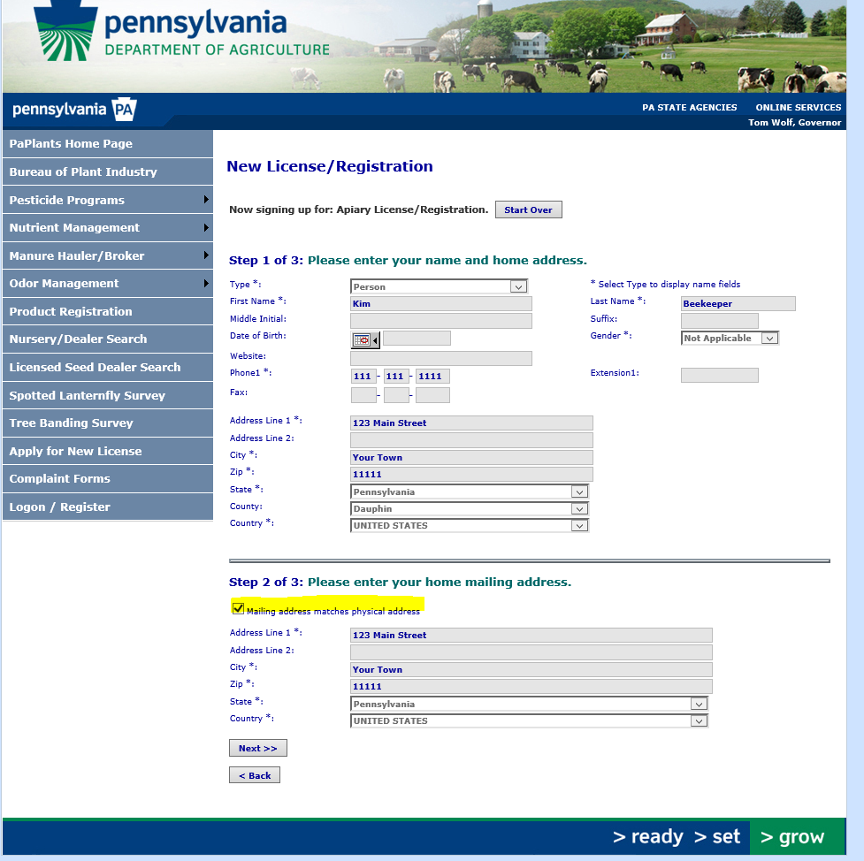

-Click “next” and complete and continue to Step 3 of 3!

-For the next step, you will be asked to enter information about your Apiary Locations (where you have your bees, also called bee yard(s).
Click on the gray rectangular box with “Add Apiary Location” printed inside.

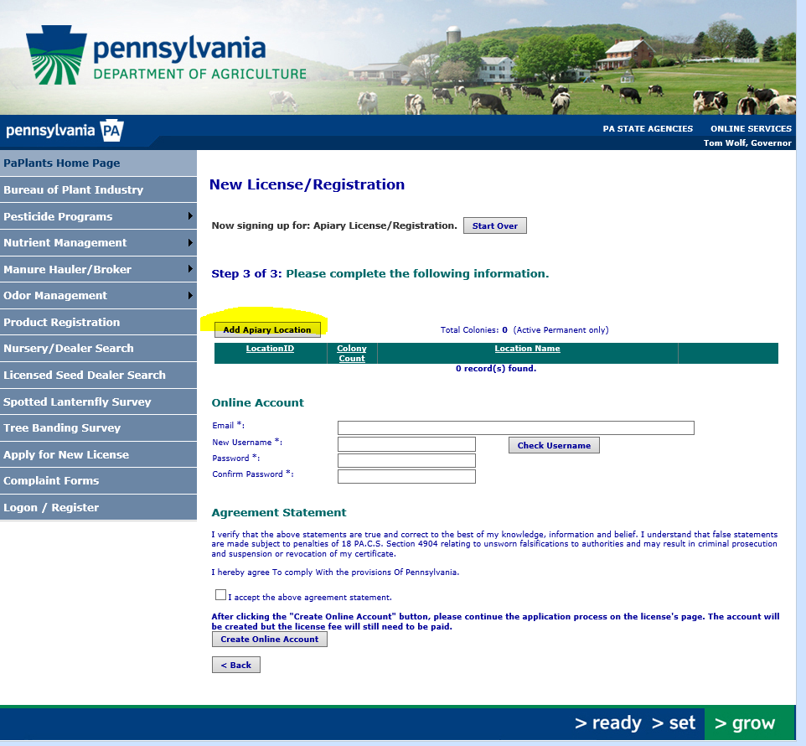

6. This will open a page titled “Apiary Location Information”.
-Follow directions for “Location Type”.
- “Live Colony Count” is the number of hives in that particular bee yard. If you do NOT have the bees yet, type in the number of colonies/hives you are planning to get. This is not the number of actual bees, it is the number of colonies of bees!
- “Township or Borough” is the township or borough which the bee yard is located. It is not necessarily the name of the town. It is fine to have more than one yard in a township or borough.
-Please fill in the location information as accurately as you can. You may click on “Plot above address on map” to see the “earth view” on the Google map. If it does not look like it is correct, please double check that the county, township, and address listed are correct. You may leave a note of any problem in the “Comments” section located above the map.

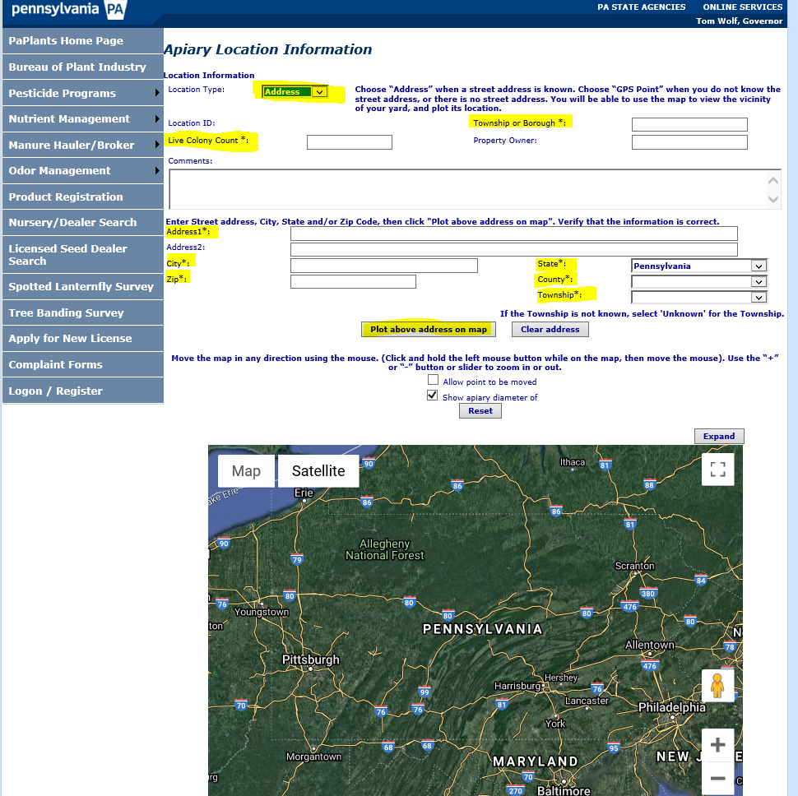
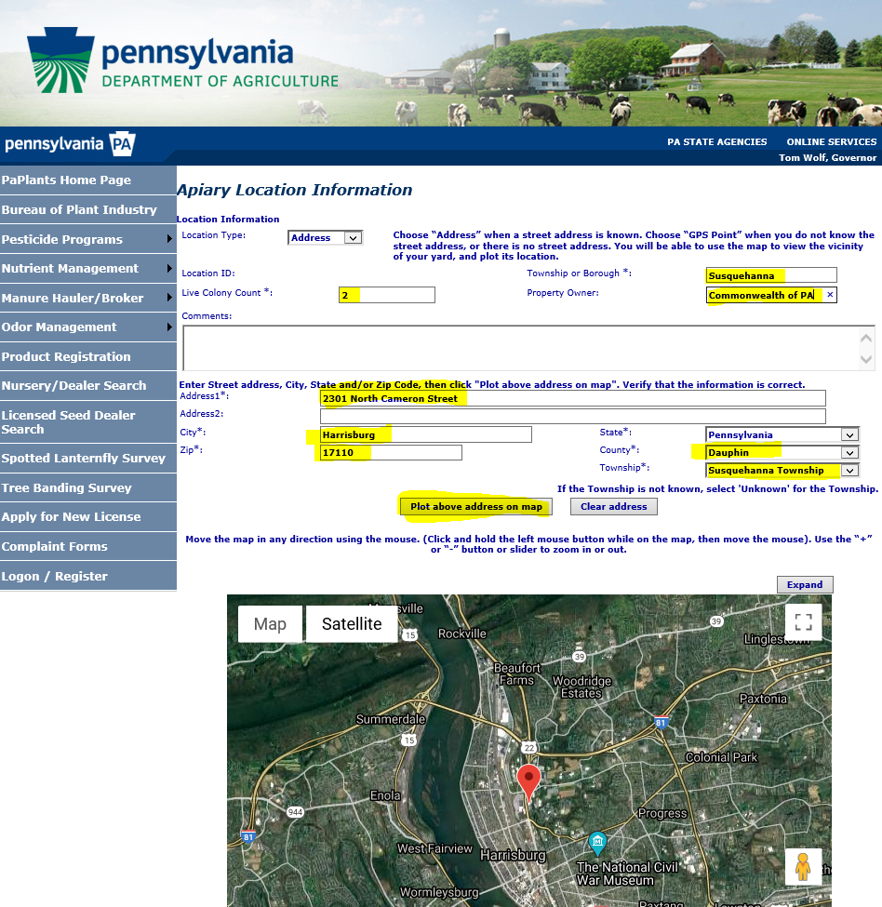

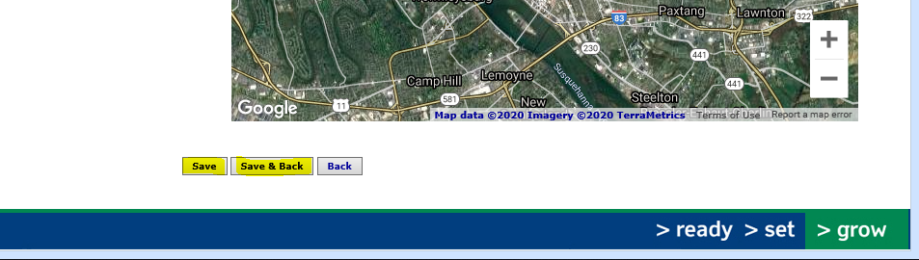
-Click on “Save” to save this bee yard in the software.
-If you have more than one bee yard, click on “Save and Back” and you will be back on the “New License/Registration - Step 3 of 3” page. Click on “Add Apiary Location” box again and type in the requested information. Note that you can see a summary of the apiary location you just entered.

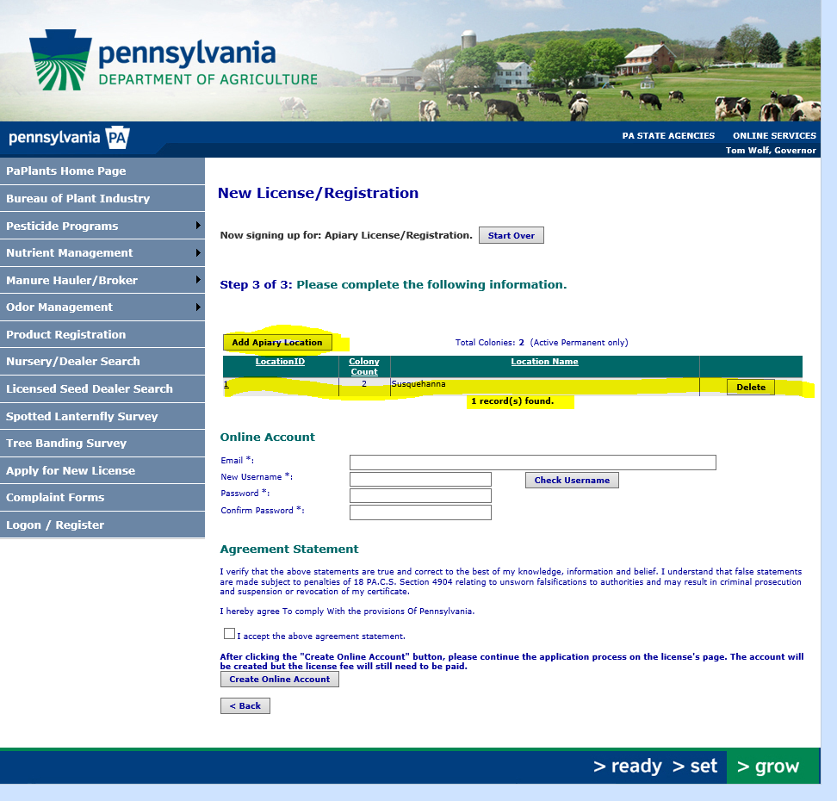

-If you need to edit something in the apiary yard locations, you can click on the underlined number of hives/colonies under “Location ID”. You may not be able to edit everything when you go back into a previously entered and saved location. You may type in changes in the “comment” box and we will make the changes for you. You will be able to make some changes when you verify information later.
-Click on “Save” and then “Save and Back”.
-The screen shot below shows 2 locations. Apiary (location) 2 has 5 colonies and Apiary 1 has 2 colonies.
-Under “Online Account”, enter your email, new user name, and password.
-Read the “Agreement Statement”. If you agree, click on the box by the words “I accept the above agreement statement.

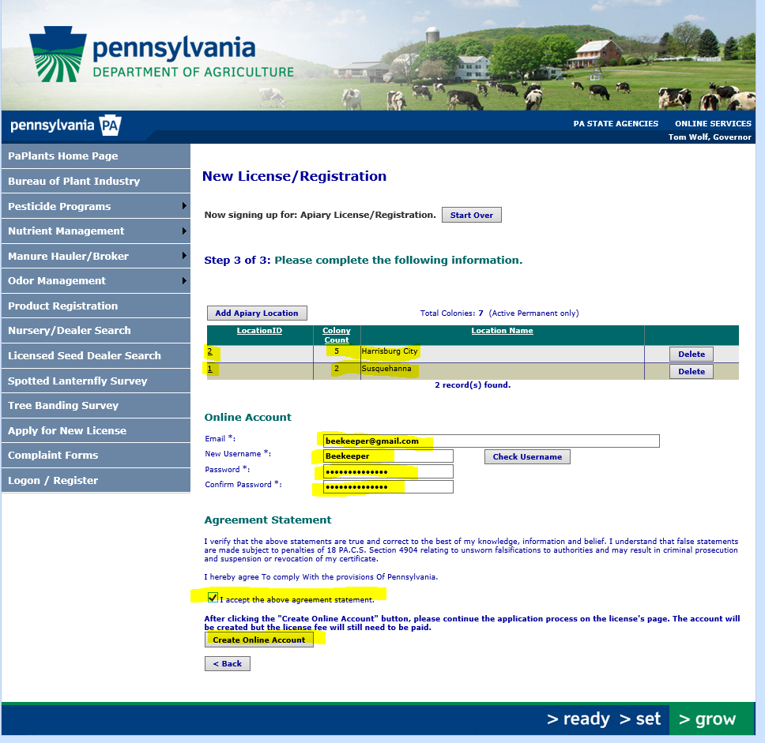

-Click on the box “Create Online Account” and “Processing…..” will show up.
-Note: if there is a problem, a box outlined in red will appear describing the problem. The problem must be corrected before you can proceed. You may have to re-enter your email, password, as well as rechecking the box before you can proceed.

7. You will now be on a page labeled “Account Home” and it will provide a summary.
-It will also say “You have a new unpaid license. Please contact the department at 717-787-4843 or via email.” IGNORE this unless you have problems. (Later, you can exit “shopping cart” and return to this page if you need to do so.)
-You may click on “Apiary” underlined and in the box labeled “Available Programs” or you may click on the “Online Shopping Cart” box in the box labeled “Online Renewals/Payments” or you may click on “1 license(s) due for renewal” in the “Account Tasks” box, or you may click on “Shopping Cart” in the upper menu. Different screens may appear depending on which link you clicked on, but you want to end up at the Shopping Cart page. Follow the directions on the page(s) you end up on. You may have to click in boxes to add a check mark, etc.

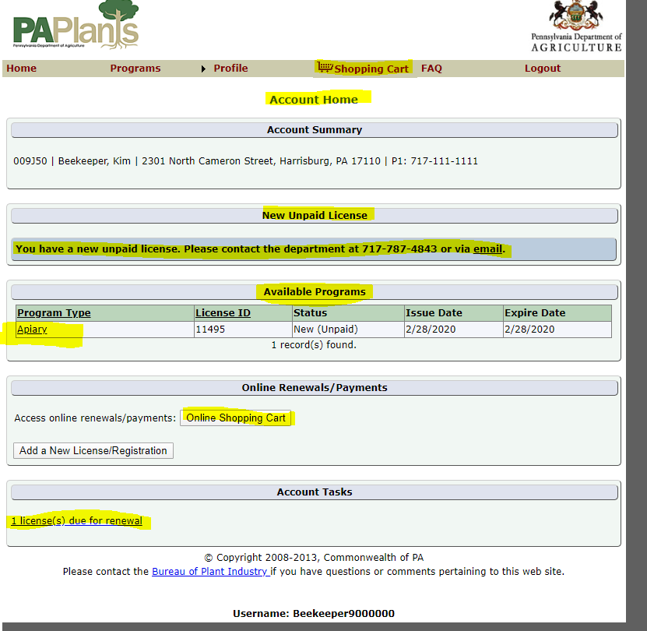
8. Shopping Cart page

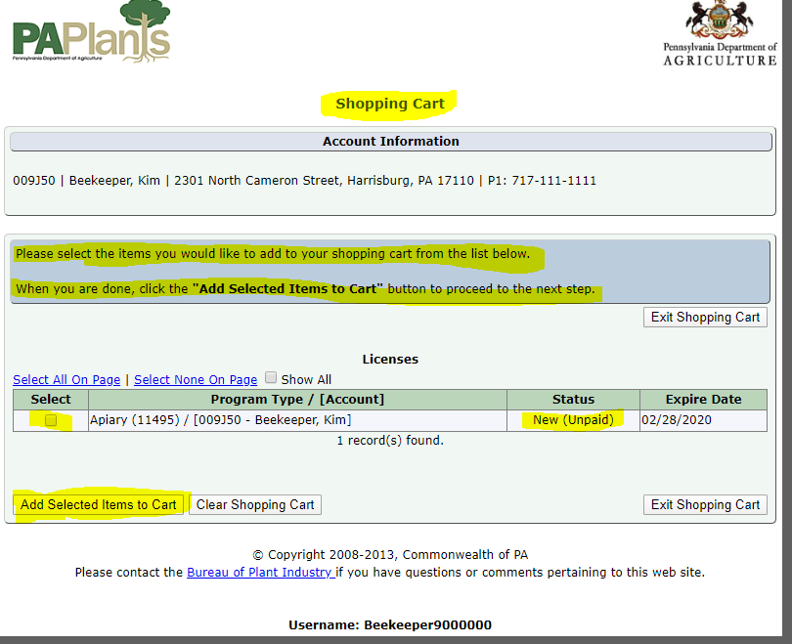

-Click on the box under the word “Select” to indicate that the Apiary License is the one you want to select.
-Click the box labeled “Add Selected Items to Cart”

9. Shopping Cart Verification page

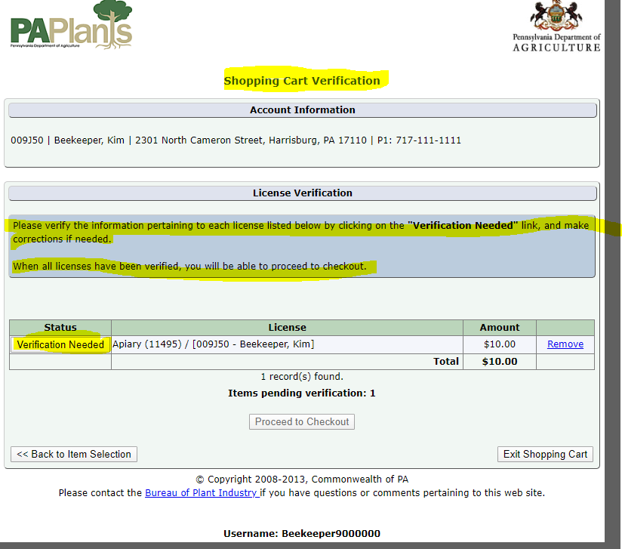

-Click on “Verification Needed”

10. License Information Verification page

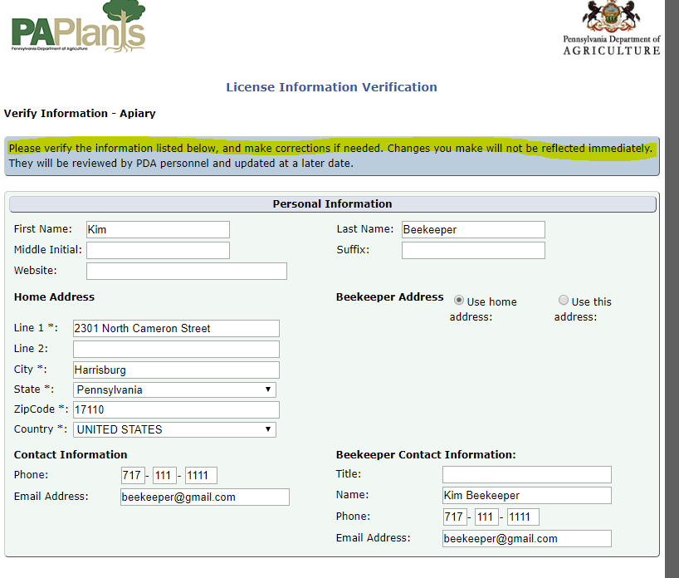
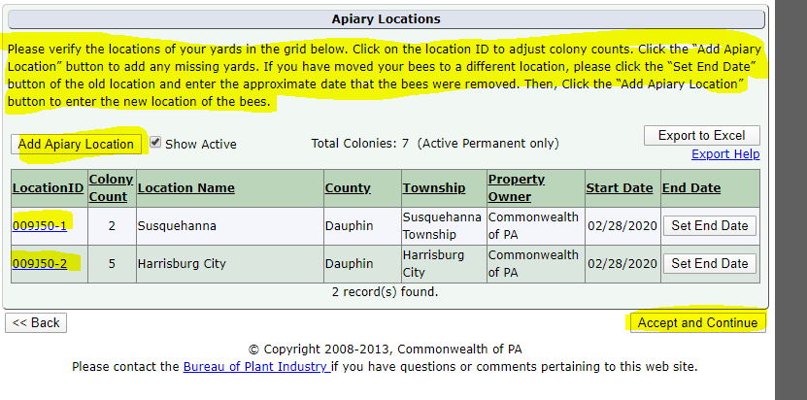

-You can make changes if there are errors. Under the “LocationID” you will see your PA Plants Id number (for this example, it is 009J50), a dash and then a number. (009J50-1 has 2 colonies) It is underlined and you can click on this to go back to view the details of the bee yard/location.

-Click on “Accept and Continue”.

11. Shopping Cart Verification page

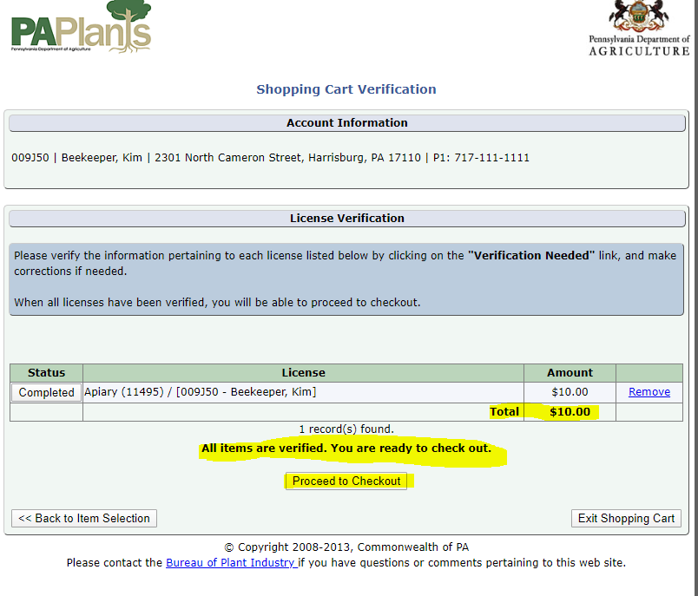
-You will see “All items are verified. You are ready to check out.”
-If you are satisfied with your entries, click on “Proceed to Checkout”.
12. Checkout page

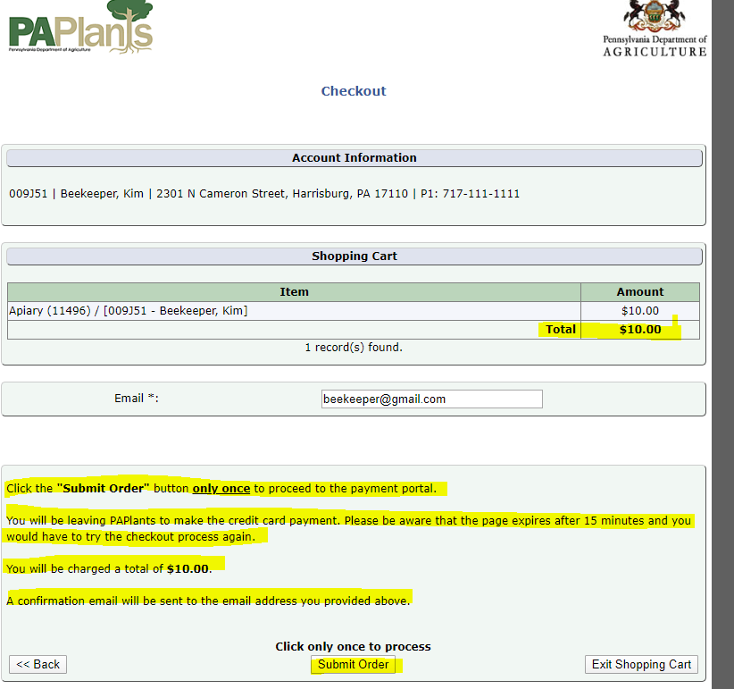

-You will be asked to enter your credit card number.
-Please click on “Submit Order” button only once.
-You should receive a confirmation email, if you entered an email account.
-Your total should be $10.

13. Payment Page

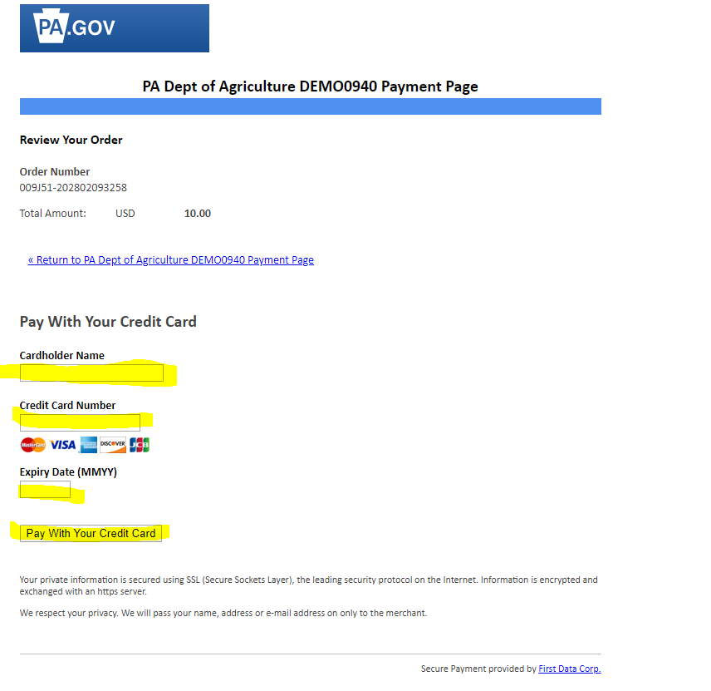

-Please enter the requested information.
-Click on “Pay with your credit card”.

- If this is a new Apiary License, then your information will be sent to the apiary section at the PA Department of Agriculture. Your new Apiary License will be sent to you after your application is reviewed.
- Remember to “Logout”.
If you do have an Apiary License and wish to update information or pay online for the FIRST time:

1. You will need your address, the address of the bee yard(s) (including county and township), and a credit card.

2. Go to the Pennsylvania Department of Agriculture’s link at https://www.paplants.pa.gov/SecurityLogin.aspx

3. It will take you to a page labeled: “Pennsylvania Department of Agriculture”.

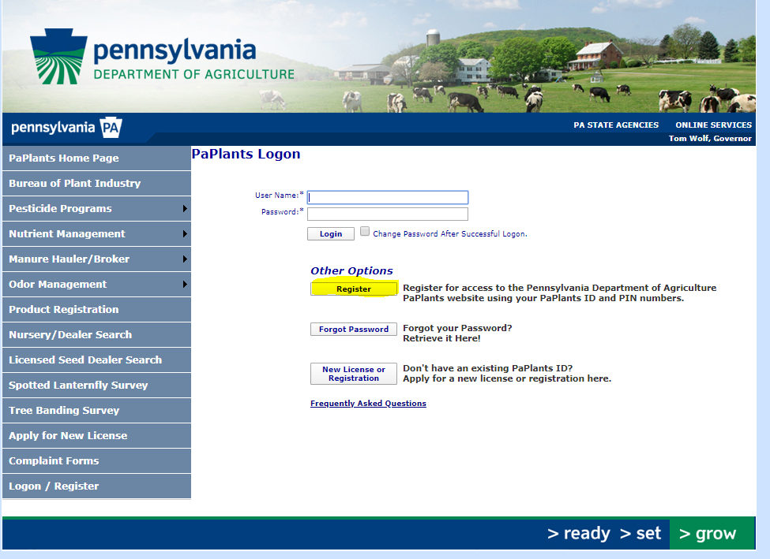

4. Register User page

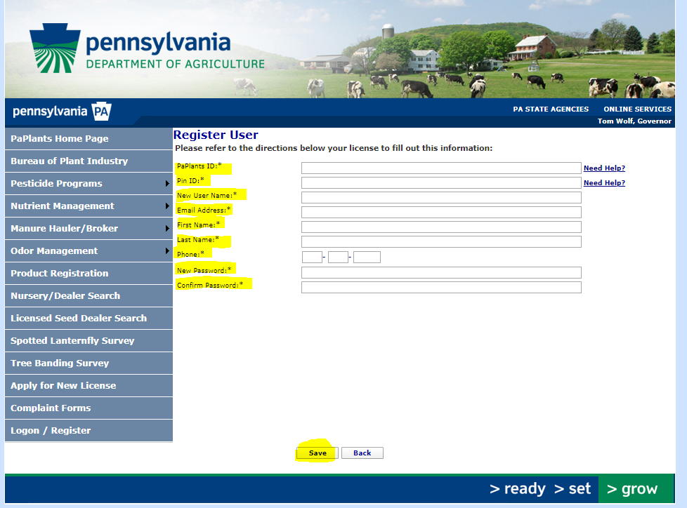
-Fill in the information. An * means the information is required.
-Your PA Plants ID and your PIN number are automatically generated by the software. The PA Plants ID can be found on your renewal form and your apiary license. The PIN number is found on your renewal form, but only until you set up a PA Plants account. You can call or email Karen Roccasecca at 717-346-9564 or kroccasecc@pa.gov and I can give them to you. You will need to create a User name and password.
-Click on “Save”.

-Example of completed Registered User page.

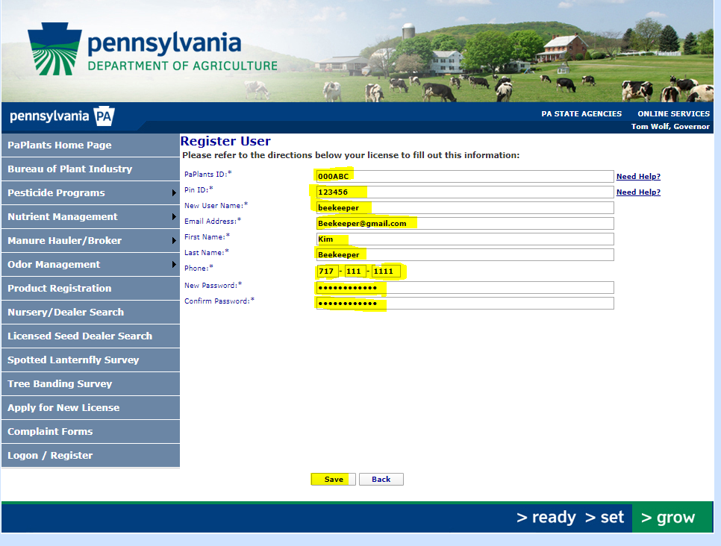

5. Apiary Program page

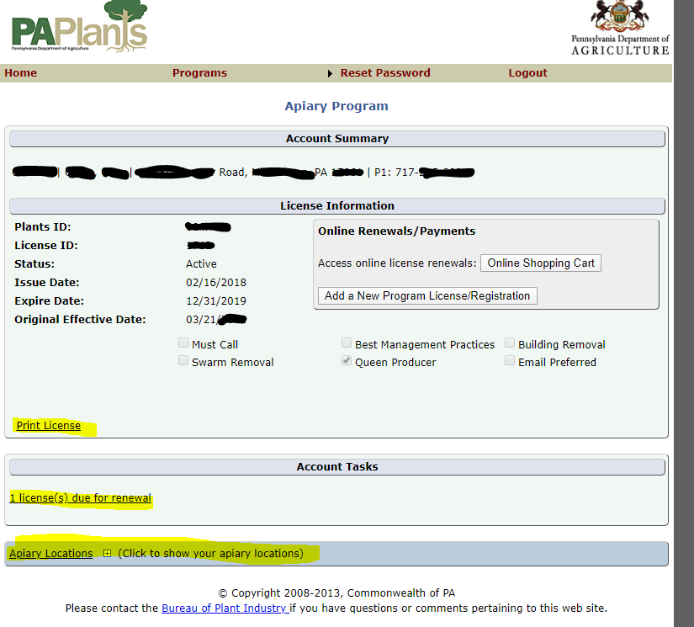
-On this page, you can “Print License” by clicking on the appropriate underlined words.
-You may also click on “1 license(s) due or renewal” to pay to renew your apiary license.
- You may click on “Apiary Locations” to view and/or update your apiary locations.

6. To renew your license
- Click on “1 license(s) due or renewal” to pay to renew your apiary license.

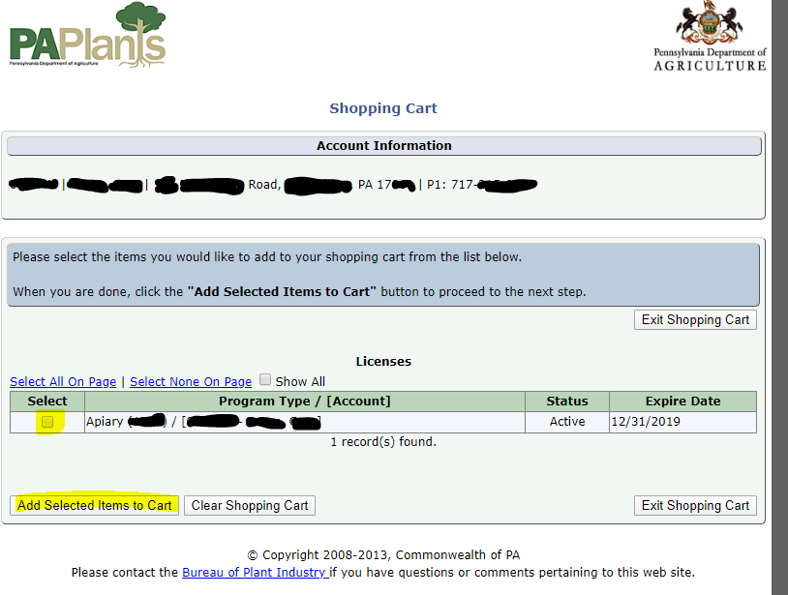
-Click on the box under “Select” to add a check mark.
-Click on “Add Selected Items to Cart”.

7. Shopping Cart Verification

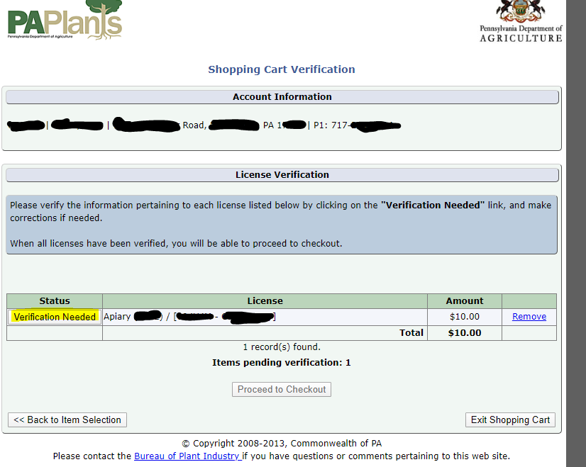

8. License Information Verification page

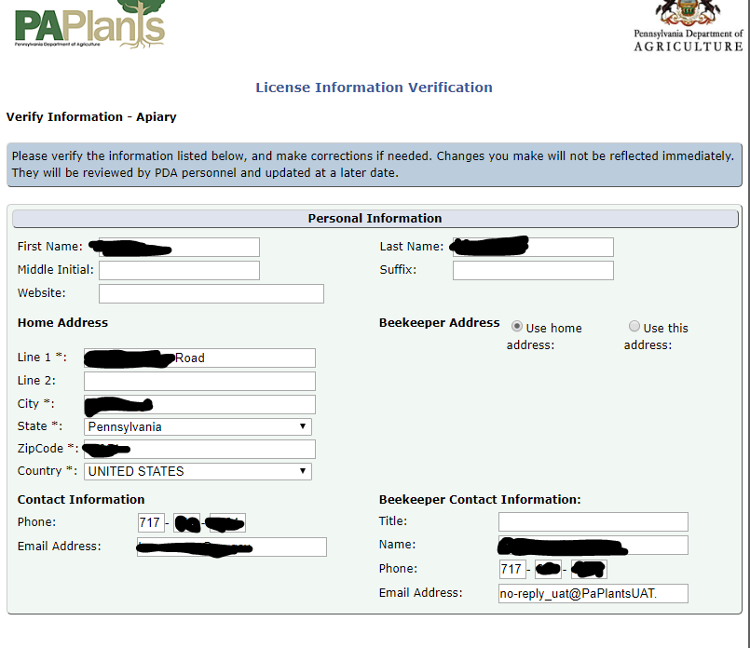
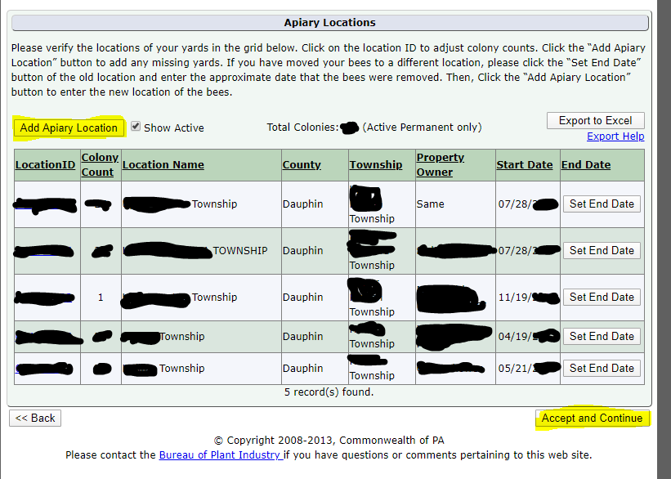

-You may add a new location by clicking the “Add Apiary Location” box and following the directions.
-If you wish to update your listed bee yards, click on the underlined individual location id number in the chart.
-Click on “Save” and then “Save and Back” to return to “License Information Verification” page.
-Click on “Accept and Continue” when ready.

9. Shopping Cart Verification page

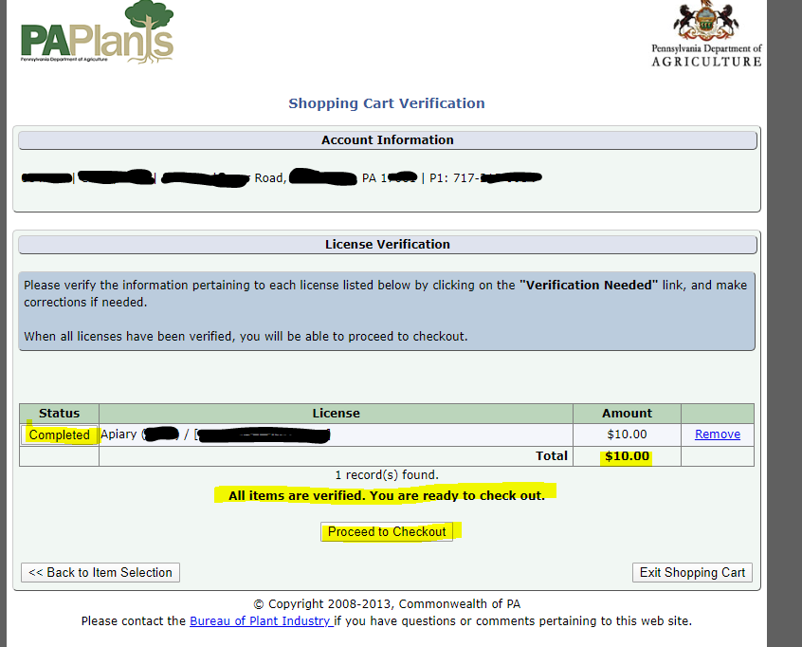
-This is what you will see after all information has been verified.
-Click on “Proceed to Checkout” to pay the $10 renewal fee.

10. Checkout page

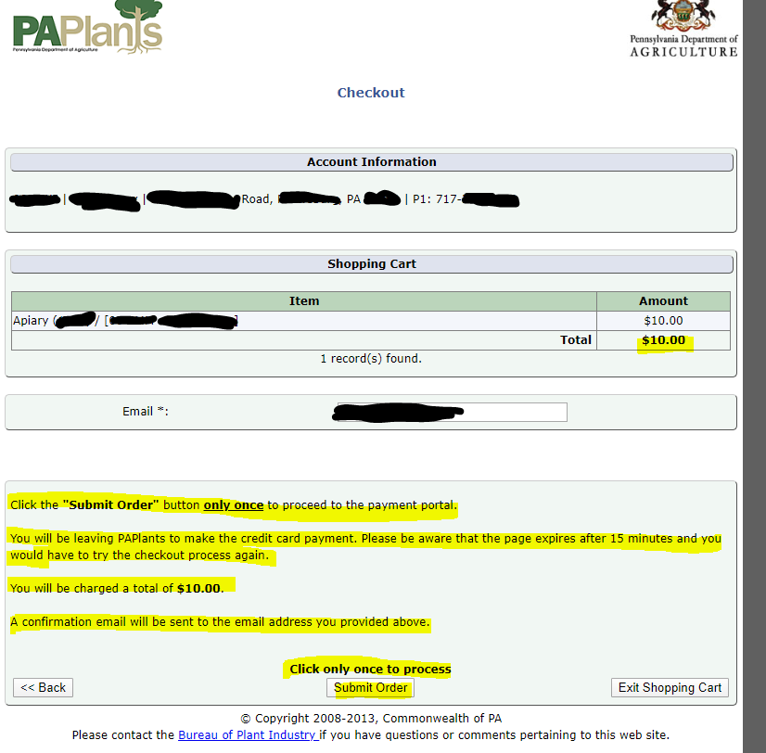
-Click on “Submit Order” one time.

11. Payment page
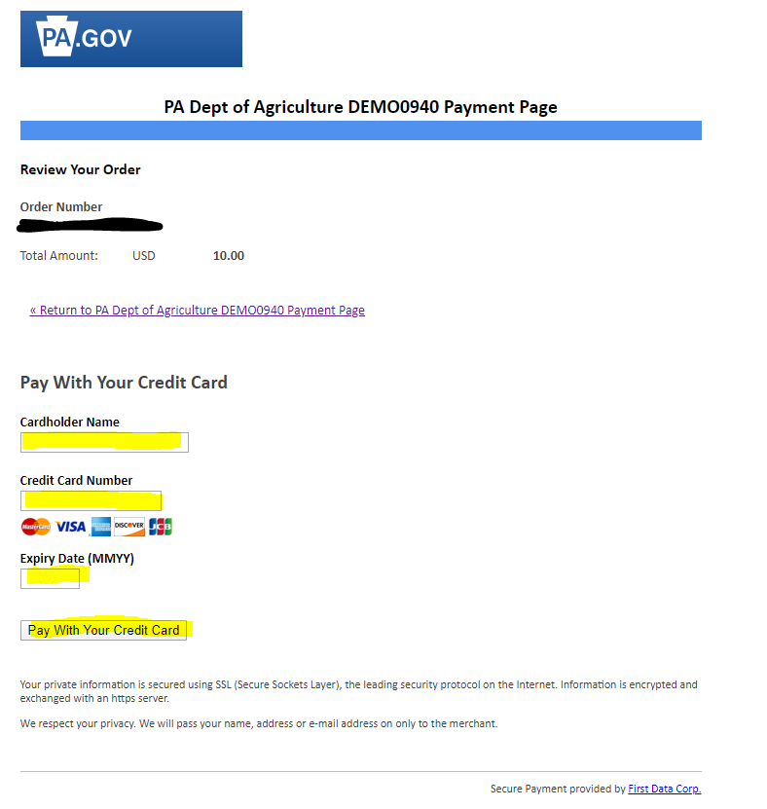
-Enter credit card information.
-Click on “Pay with your credit card”.
-You should receive an email and/or a screen message about the payment.

If you do have an Apiary License and have already registered with PA Plants for access to your PA Plants account:
1. Go to the Pennsylvania Department of Agriculture’s link at https://www.paplants.pa.gov/SecurityLogin.aspx
-It will take you to a page labeled: “Pennsylvania Department of Agriculture”.

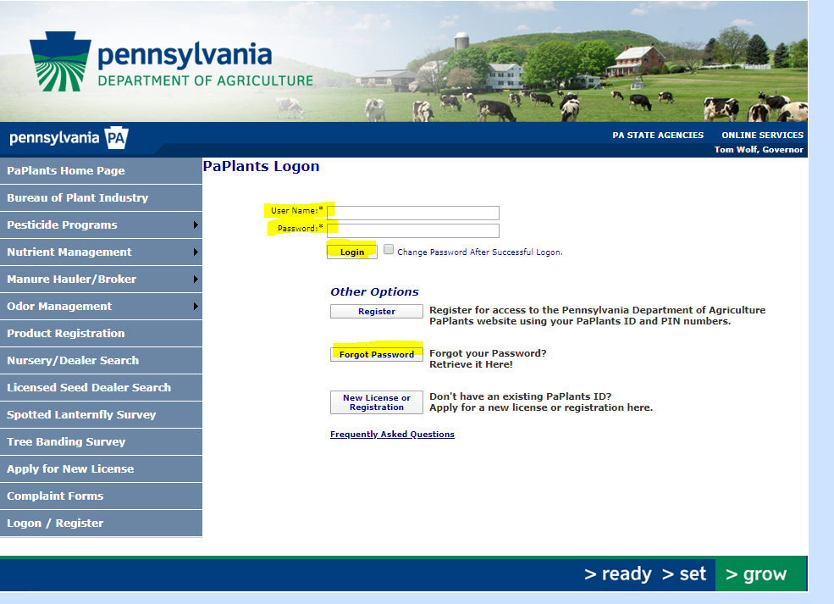

-Fill in your “User Name” and “Password”.
-Click on “Login”.
-Note- you may click on “Forgot Password” or “Frequently Asked Questions” for additional information.

2. Apiary Program page

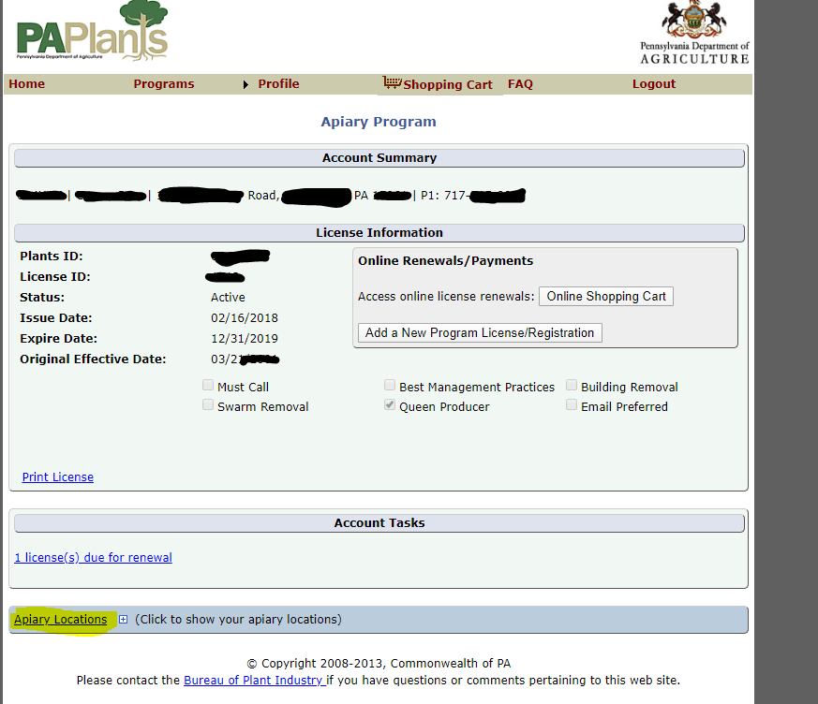

-Click on “Apiary Location” to view your bee yard information.
This is what the page looks like:

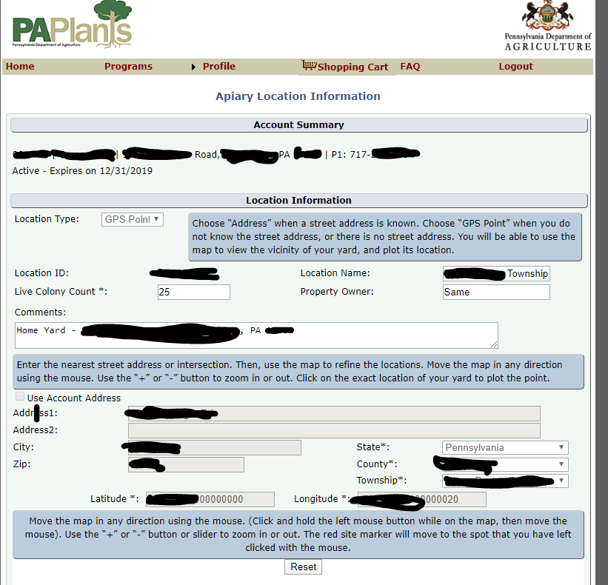

-There is a Google map here too.
-Click on “Save and Back” to return to Apiary Program page.
If you added or closed a yard and want to update your account record, you can start the process on this page.
To close a yard, click on “Set End Date” in the “End Date” column on the chart showing the apiary locations.

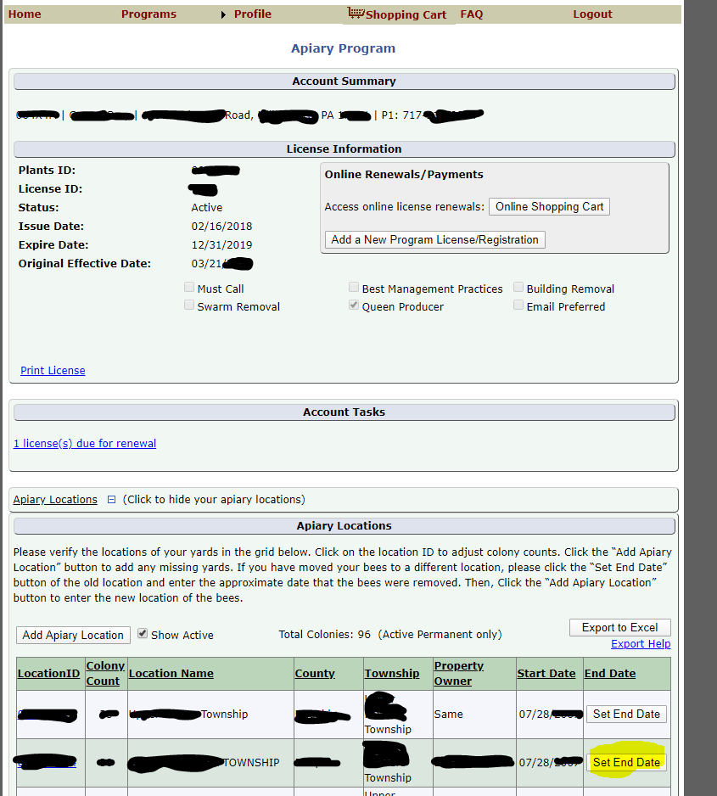

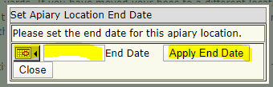

-This little box will pop up.
-Fill in the approximate end date.
-Click on “Apply End Date”.

-To add a new bee yard location, click on “Add Apiary Location”.
-To view open and closed yards, click on the “Show Active” box. When the check mark is removed, all yards will be visible.
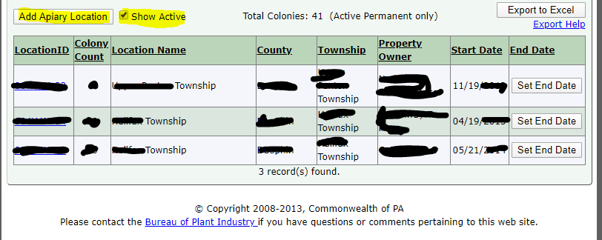

FAQ
1. Can I renew my Apiary License online?
-Yes, go to the login/register page. Enter your information requested, including “user name” and “password” that you made up when you registered online, OR click on “forgot password” if you do not remember your password.
- If you have NOT already registered online, you can set up an account by entering your PA Plants Id # and your PIN number which are printed on the bottom of the apiary renewal sheet you receive in the mail from the PA Department of Agriculture. Do NOT set up a brand-new account! You have an account in PA Plants already. You will now be able to access it.
2. After the beekeeper has an account established, he or she may go online and add bee yards, number of colonies, etc.
3. There are additional FAQ on the bottom of the “Logon” page.
5. Please - call or email Karen Roccasecca 717-346-9567 (kroccasecc@pa.gov) if you have problems or make a mistake which you can’t fix! I can maybe fix the mistake, help walk you through problems or contact the IT people who can help.

Revised February 28, 2020 KNR

